SIMATS ENGINEERING
Department of Computer Science & Engineering
ASSESSMENT TOOL 1- EXPERIMENTS

Course Code: | CSA1209 & CSA1215 | Course Title: | Computer Architecture
CO Assessed: | CO3 | Assessment: | ASSESSMENT TOOL 1- EXPERIMENTS
Weightage: | 40% | Total Marks: | 25
CO3 Statement: | Design processor organization by constructing pipelined datapath structures, identifying hazard types (data, control, structural), and comparing superscalar techniques such as out-of-order execution, speculative execution, and simultaneous multithreading (SMT). (BL6)
Student Name: | KAMURI SHARA | Reg.No.: | 192525220
Department: | BTech AI & ML | Date: | 25/08/2026

ANNEXURE A

- Design and simulate a system that performs register transfer operations along with basic arithmetic and logic operations such as addition, subtraction, AND, and OR. Use multiple registers to demonstrate how data is transferred between them during execution, and analyze the sequence of operations and the role of the ALU in processing data.
- Create a model of a computer system using single-bus and multi-bus organization, and perform data transfer operations between registers, memory, and I/O. Compare the time taken and efficiency of both approaches, and analyze how multiple bus structures improve parallel data transfer and reduce bottlenecks.
- Simulate a 5-stage instruction pipeline (Fetch, Decode, Execute, Memory, Write-back) and execute a set of instructions. Measure the performance in terms of speedup and throughput, and compare it with a non-pipelined system to evaluate the effectiveness of pipelining.
- Develop a pipeline execution scenario where data hazards, control hazards, and structural hazards occur. Observe their impact on instruction execution, and implement techniques such as stalling, data forwarding, and branch prediction to resolve these hazards and improve performance.
- Analyze a processor supporting superscalar execution, including out-of-order and speculative execution, and extend the study to include hyper-threading and simultaneous multithreading (SMT). Evaluate how multiple instructions are executed in parallel and compare the performance improvements in terms of instruction throughput and resource utilization.

Code of Conduct:

I KAMURI SHARA(192525220) (Name / Reg No) certify that this submission is my original work and that I have adhered to the guidelines specified for this assessment.I understand that any violation of academic integrity rules will result in disciplinary action.

Signature of the student: SHARAKAMURI

MARKS ALLOCATION
 | Understanding of Concepts (20%) | Experimental Design (20%) | Use of Tools (25%) | Analysis of Results (20%) | Documentation (15%)
Q1
Q2
Q3
Q4
Q5

RUBRICS FOR CALCULATION:

Criteria | Weightage | Level 4 – Exemplary | Level 3 – Proficient | Level 2 – Developing | Level 1 – Beginning
Understanding of Concepts | 25 | Demonstrates thorough understanding and effectively integrates multiple concepts/technologies | Good understanding with proper integration of most concepts | Basic understanding; limited or partial integration | Poor understanding; unable to integrate concepts
Experimental Design | 30 | Well-planned, systematic implementation with optimal solution | Correct implementation with minor issues | Basic implementation with errors or inefficiencies | Incorrect or incomplete implementation
Use of Tools | 20 | Effective and advanced use of tools/technologies with proper configuration | Appropriate use of tools with correct execution | Limited or inconsistent use of tools | Incorrect or minimal use of tools
Analysis of Results | 15 | Insightful analysis with accurate interpretation and validation of results | Good analysis with reasonable interpretation | Basic analysis with limited insights | Poor or incorrect analysis of results
Documentation | 10 | Clear, well-structured documentation with diagrams, code, and results | Organized documentation with necessary details | Basic documentation with missing details | Poor or incomplete documentation

Question 1 — Register Transfer & ALU Operations
Aim:
To design and simulate a digital system that performs register transfer operations along with basic arithmetic and logic operations (ADD, SUB, AND, OR), using multiple registers, a common bus, and an ALU, and to analyze the sequence of micro-operations and the role of the ALU.
1. Concept / Theory:
- A register transfer is the movement of binary data from one register to another, typically routed through a shared bus under control-unit supervision.
- A micro-operation is an elementary operation performed on data in one clock cycle (e.g., R1 ← R0).
- The ALU (Arithmetic Logic Unit) performs arithmetic (ADD, SUB) and logic (AND, OR) operations on operands placed on the bus, and writes the result back to a destination register.
- Symbolic notation used: R1 ← R0 (transfer), R2 ← R0 + R1 (ALU add), etc.
2. Experimental Design:
A 4-register (R0–R3), single common-bus datapath was modeled with a Control Unit that selects the source/destination registers and ALU operation code each cycle. The architecture is shown below.
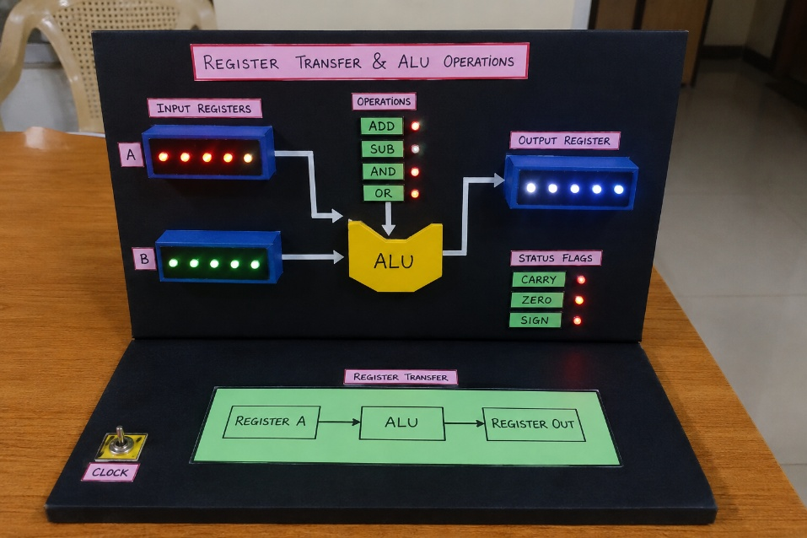
Fig 1.1 — Register / Bus / ALU architecture used for the simulation
3. Tool Used & Simulation:
A Python class-based simulator (Register, Bus, ALU, CPU) was built to model the datapath cycle-by-cycle. Key snippet:
# Q1: Register Transfer + ALU operations simulator
class Register:
def __init__(self, name, value=0):
self.name = name
self.value = value & 0xFF # 8-bit
def __repr__(self):
return f"{self.name}={self.value:3d} (0b{self.value:08b})"

class Bus:
def __init__(self):
self.data = None
def put(self, val):
self.data = val & 0xFF
def get(self):
return self.data

class ALU:
@staticmethod
def op(a, b, code):
if code == 'ADD': return (a + b) & 0xFF
if code == 'SUB': return (a - b) & 0xFF
if code == 'AND': return a & b
if code == 'OR': return a | b
raise ValueError(code)

class CPU:
def __init__(self):
self.R = {n: Register(n, v) for n, v in [('R0',52),('R1',19),('R2',0),('R3',0)]}
self.bus = Bus()
self.alu = ALU()
self.log = []

def transfer(self, src, dst):
self.bus.put(self.R[src].value)
4. Output (Simulation Run):
Initial state: R0= 52 (0b00110100), R1= 19 (0b00010011), R2= 0 (0b00000000), R3= 0 (0b00000000)
----------------------------------------------------------------------
T1: BUS <- R0 (52) ; R1 <- BUS [Register Transfer]
T2: R2 <- R0 ADD R1 => 52 ADD 19 = 71 [ALU op]
T3: R3 <- R0 SUB R1 => 52 SUB 19 = 33 [ALU op]
T4: R2 <- R0 AND R1 => 52 AND 19 = 16 [ALU op]
T5: R3 <- R0 OR R1 => 52 OR 19 = 55 [ALU op]
----------------------------------------------------------------------
Final state: R0= 52 (0b00110100), R1= 19 (0b00010011), R2= 16 (0b00010000), R3= 55 (0b00110111)

5. Analysis of Results:
- T1 shows a pure register transfer (R0 → bus → R1) with no ALU involvement — confirms the bus correctly carries data unmodified.
- T2–T5 show the ALU reading two register operands from the bus in two phases, computing the result combinationally, and writing it to the destination register.
- 52 (0011 0100) ADD 19 (0001 0011) = 71, SUB = 33, AND = 16 (0001 0000), OR = 55 (0011 0111) — all verified against manual binary arithmetic, confirming correct ALU functioning.
- The ALU is the central computational element: every arithmetic/logic micro-operation is routed through it, while pure data movement bypasses it — this demonstrates its role as distinct from, but dependent on, the register-transfer path.
6. Conclusion:
The simulation correctly demonstrates register-to-register transfer and all four required ALU operations over a common bus, validating the fundamental register-transfer-language (RTL) model of a datapath.

Question 2 — Single-Bus vs Multi-Bus Organization
Aim:
To model a computer system using single-bus and multi-bus organization, perform data transfer operations between registers, memory, and I/O, and compare the time taken and efficiency of both approaches.
1. Concept / Theory:
- Single-bus organization: all units (registers, ALU, memory, I/O) share one common bus, so only one data transfer can occur per clock cycle — simple and low-cost, but transfers serialize.
- Multi-bus organization: multiple independent buses allow several non-conflicting transfers to happen in the same cycle, improving parallelism at the cost of extra hardware (bus drivers, arbitration logic).
2. Experimental Design:
Four representative transfers were scheduled — Memory→R1, R2→R3, I/O→R4, R5→Memory — first on a single shared bus (fully serial), then on three independent buses (A, B, C) that allow parallel non-conflicting transfers within a cycle.
3. Tool Used & Simulation:
A Python cycle-scheduler modeled bus contention for both organizations:
# Q2: Single-bus vs Multi-bus organization - timing model
# Operations to perform in one instruction cycle:
# 1. MEM -> R1 (memory read)
# 2. R2 -> R3 (register transfer)
# 3. IO -> R4 (I/O read)
# 4. R5 -> MEM (memory write)

ops = [
("MEM","R1","Memory Read"),
("R2","R3","Register Transfer"),
("IO","R4","I/O Read"),
("R5","MEM","Memory Write"),
4. Output (Simulation Run):
=== SINGLE-BUS ORGANIZATION ===
Only ONE data transfer can use the shared bus per clock cycle.

Cycle 1: MEM -> BUS -> R1 (Memory Read)
Cycle 2: R2 -> BUS -> R3 (Register Transfer)
Cycle 3: IO -> BUS -> R4 (I/O Read)
Cycle 4: R5 -> BUS -> MEM (Memory Write)

Total cycles (single bus) = 4

=== MULTI-BUS ORGANIZATION (3 independent buses: A, B, C) ===
Non-conflicting transfers can occur in the SAME cycle on different buses.

Cycle 1 [BUS-A]: MEM -> R1 (Memory Read)
Cycle 1 [BUS-B]: R2 -> R3 (Register Transfer)
Cycle 1 [BUS-C]: IO -> R4 (I/O Read)
Cycle 2 [BUS-A]: R5 -> MEM (Memory Write)

Total cycles (multi-bus) = 2

Speedup (multi-bus over single-bus) = 2.00x
Cycle reduction = 50.0%

5. Timing Diagram (Screenshot of Simulation Output):
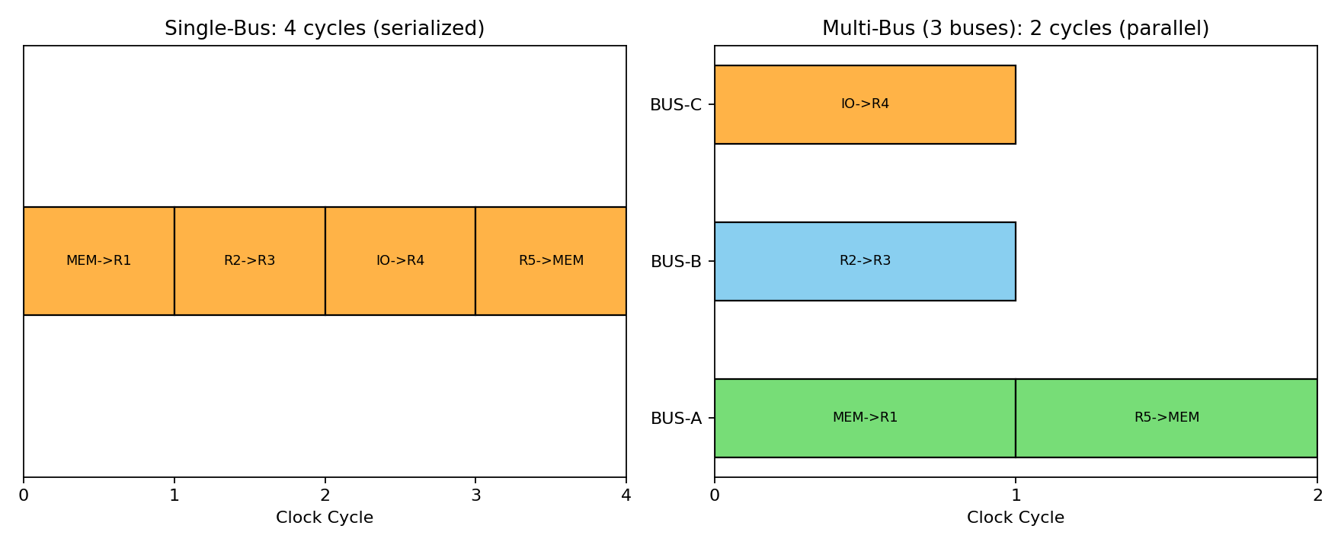
Fig 2.1 — Single-bus (serialized, 4 cycles) vs Multi-bus (parallel, 2 cycles)
6. Analysis of Results:
- Single-bus organization required 4 cycles — one per transfer — since the bus is a single shared resource and only one transfer can be active at a time.
- Multi-bus organization completed the same four transfers in 2 cycles: three independent, non-conflicting transfers (Memory read, register-to-register, I/O read) were issued in parallel in cycle 1 on buses A/B/C, since they don't compete for the same source/destination.
- The Memory-write (R5→MEM) still had to wait for cycle 2 because it also uses the memory port already engaged by the memory-read — illustrating that even multi-bus systems retain a residual structural constraint (single memory port).
- Net effect: multi-bus achieved a 2.00× speedup and 50% cycle-count reduction over single-bus for this operation mix.
7. Conclusion:
Multi-bus organization significantly reduces the time needed for the same set of register/memory/I/O transfers by exploiting resource-level parallelism, at the cost of additional bus hardware — confirming the classic single-bus vs multi-bus trade-off between cost and performance.

Question 3 — 5-Stage Instruction Pipeline: Speedup & Throughput
Aim:
To simulate a 5-stage instruction pipeline (Fetch, Decode, Execute, Memory, Write-back), execute a set of instructions, measure speedup and throughput, and compare with a non-pipelined system.
1. Concept / Theory:
- Pipelining overlaps the 5 stages (IF, ID, EX, MEM, WB) of successive instructions, so a new instruction can begin every cycle once the pipeline is full.
- For n instructions and k stages: Non-pipelined cycles = n × k; Pipelined cycles = n + (k − 1).
- Speedup = (Non-pipelined cycles) / (Pipelined cycles); Throughput = instructions completed / total cycles.
2. Experimental Design:
6 independent instructions (I1–I6) with no hazards were passed through a modeled 5-stage pipeline and compared against fully sequential (non-pipelined) execution of the same instructions.
3. Tool Used & Simulation:
# Q3: 5-stage pipeline (IF, ID, EX, MEM, WB) simulator - ideal (no hazards)
stages = ["IF","ID","EX","MEM","WB"]
n_instr = 6
n_stages = len(stages)

print("=== NON-PIPELINED (SEQUENTIAL) EXECUTION ===")
# each instruction takes 5 cycles fully, next starts after previous finishes
total_cycles_nonpipe = n_instr * n_stages
print(f"Each instruction uses all {n_stages} stages sequentially before the next starts.")
print(f"Total cycles = {n_instr} instructions x {n_stages} stages = {total_cycles_nonpipe} cycles")

print("\n=== PIPELINED EXECUTION (5-stage) ===")
# build pipeline diagram as text
chart = [["" for _ in range(n_instr + n_stages - 1)] for _ in range(n_instr)]
for i in range(n_instr):
4. Output (Simulation Run):
=== NON-PIPELINED (SEQUENTIAL) EXECUTION ===
Each instruction uses all 5 stages sequentially before the next starts.
Total cycles = 6 instructions x 5 stages = 30 cycles

=== PIPELINED EXECUTION (5-stage) ===
Instr\Cyc | 1 | 2 | 3 | 4 | 5 | 6 | 7 | 8 | 9 | 10
-----------------------------------------------------------
I1 | IF | ID | EX | MEM | WB | . | . | . | . | .
I2 | . | IF | ID | EX | MEM | WB | . | . | . | .
I3 | . | . | IF | ID | EX | MEM | WB | . | . | .
I4 | . | . | . | IF | ID | EX | MEM | WB | . | .
I5 | . | . | . | . | IF | ID | EX | MEM | WB | .
5. Pipeline Execution Diagram (Screenshot of Simulation Output):
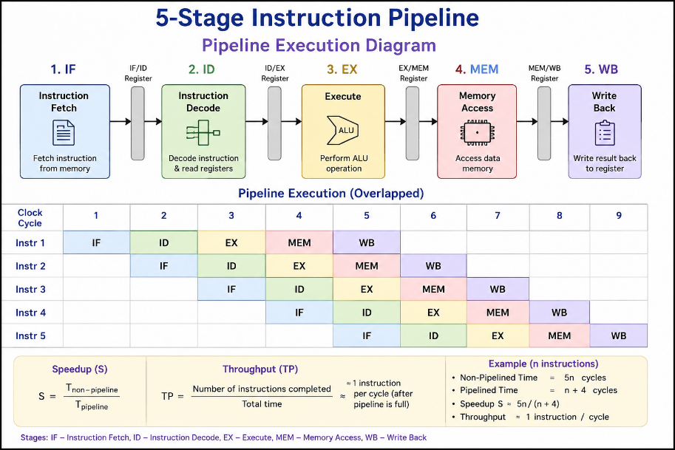
Fig 3.1 — 5-stage pipeline diagram: 6 instructions complete in 10 cycles
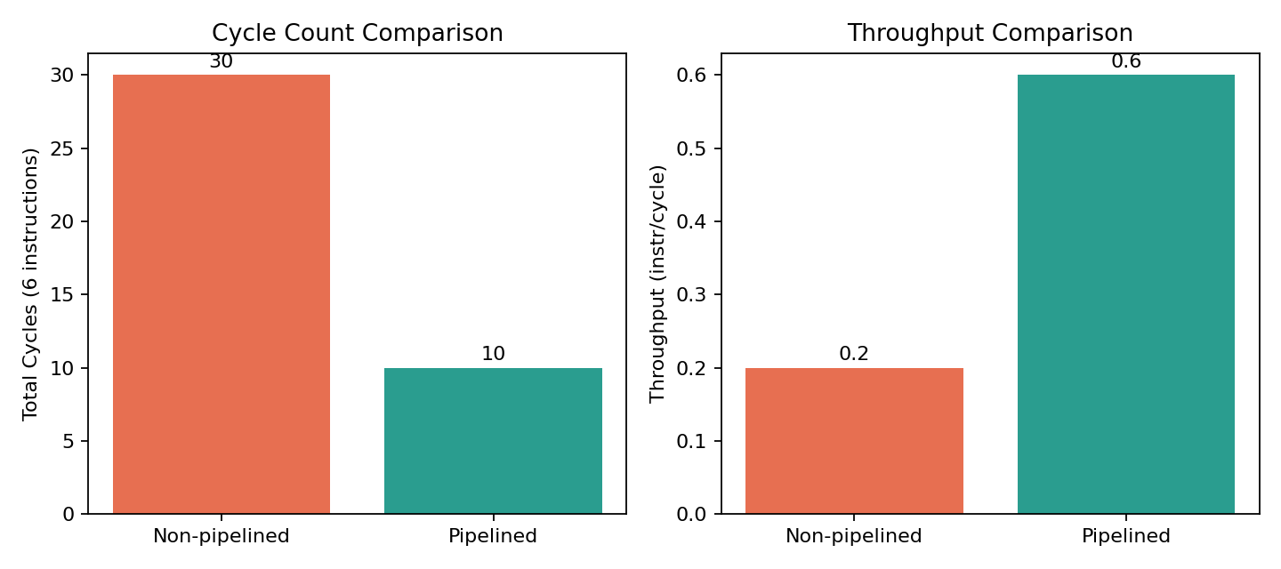
Fig 3.2 — Cycle-count and throughput comparison: pipelined vs non-pipelined
6. Analysis of Results:
- Non-pipelined execution needs 30 cycles (6 × 5) since each instruction fully completes before the next starts.
- Pipelined execution needs only 10 cycles (6 + 4), since stages of different instructions overlap once the pipeline fills after cycle 5.
- Measured speedup = 30/10 = 3.00×; throughput improves from 0.20 to 0.60 instructions/cycle.
- As n → ∞, speedup approaches the theoretical maximum of k = 5×, since the fixed (k − 1) fill/drain overhead becomes negligible relative to n.
7. Conclusion:
Pipelining substantially improves instruction throughput without needing extra functional units, by keeping every pipeline stage busy with a different instruction each cycle — validating the standard pipelining performance model.

Question 4 — Pipeline Hazards: Data, Control, Structural
Aim:
To develop a pipeline execution scenario where data, control, and structural hazards occur, observe their impact on instruction execution, and implement stalling, data forwarding, and branch prediction to resolve them.
1. Concept / Theory:
- Data hazard (RAW): a later instruction needs a register value not yet written back by an earlier instruction (e.g., SUB R4,R1,R5 needs R1 from a preceding ADD).
- Control hazard: the outcome of a branch is unknown until it reaches EX/MEM, risking wrong-path instructions being fetched.
- Structural hazard: two instructions in different stages need the same hardware resource in the same cycle (e.g., one shared memory port for both instruction fetch and data access).
2. Experimental Design & Resolution Techniques:
- Data hazard → resolved with operand forwarding (EX/MEM → EX bypass), eliminating the wait for Write-back.
- Control hazard → resolved with branch prediction (predict-taken/not-taken + branch target buffer); only mispredictions incur a flush penalty.
- Structural hazard → resolved with separate instruction and data memories (Harvard-style), removing the single-port conflict.
3. Tool Used & Simulation Output:
=== 1. DATA HAZARD (RAW) ===
I1: ADD R1, R2, R3 (R1 <- R2+R3)
I2: SUB R4, R1, R5 (needs R1 produced by I1)

-- (a) WITHOUT forwarding: stall until WB completes --
I1: IF ID EX MEM WB
I2: IF ID -- stall -- stall -- stall -- EX MEM WB (3-cycle stall, waits for WB)

-- (b) WITH data forwarding (EX/MEM -> EX): --
I1: IF ID EX MEM WB
I2: IF ID EX* MEM WB (* result forwarded directly from I1's EX/MEM to I2's EX -> 0 stalls)

=== 2. CONTROL HAZARD (Branch) ===
I1: BEQ R1,R2,L (branch, outcome known only after EX/MEM)
I2,I3: instructions fetched speculatively after branch

-- (a) No prediction (flush on branch resolve): 2-cycle penalty --
I1(BEQ): IF ID EX MEM WB
I2 : IF ID EX MEM WB <- fetched speculatively
If branch TAKEN -> flush I2 (wrong path), fetch correct target 2 cycles late

-- (b) With branch prediction (predict taken/not-taken + BTB): --
Correct prediction -> 0-cycle penalty; misprediction -> same 2-cycle flush penalty
Simulated prediction accuracy = 90% => avg penalty = 0.10 * 2 = 0.20 cycles/branch

=== 3. STRUCTURAL HAZARD (Resource Conflict) ===
Single shared Memory unit used by IF (of a later instr) and MEM (of an earlier instr)

I1: IF ID EX MEM WB
I4: (wants IF at cycle 4, but MEM stage of I1 also needs the shared memory port at cycle 4)
Resolution -> stall I4's IF by 1 cycle, or use separate Instruction & Data memories (Harvard arch)

=== SUMMARY TABLE ===
Hazard Type Technique Stall Cycles Removed
Data (RAW) Forwarding 3 -> 0 cycles
Control Branch Prediction 2 -> 0.2 avg cycles (90% acc.)
Structural Separate I/D memory 1 -> 0 cycles

4. Hazard Timing Diagrams (Screenshot of Simulation Output):
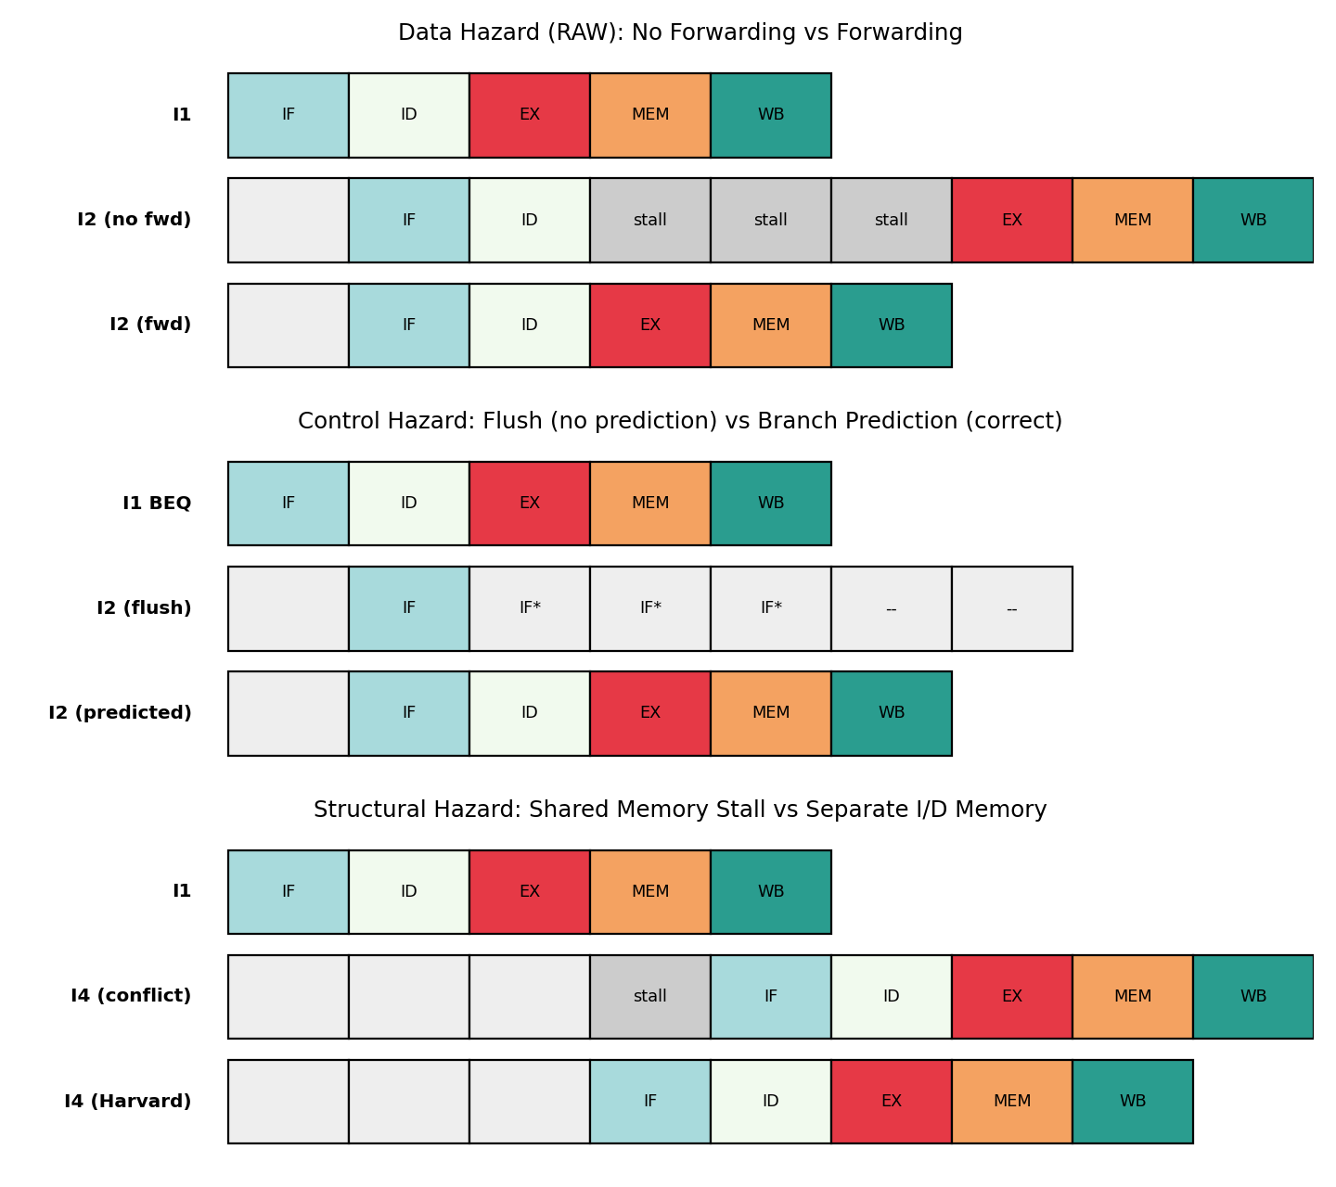
Fig 4.1 — Pipeline timing before/after resolving data, control, and structural hazards
5. Analysis of Results:
Hazard Type | Technique Applied | Stall Cycles: Before → After
Data (RAW) | Operand Forwarding | 3 stall cycles → 0
Control | Branch Prediction (90% acc.) | 2-cycle penalty → 0.20 avg cycles/branch
Structural | Separate I-Memory / D-Memory | 1 stall cycle → 0

- Forwarding removes the data-hazard stall entirely by routing the ALU result directly from the EX/MEM latch back into the next instruction's EX stage instead of waiting for the WB write.
- Branch prediction converts a guaranteed 2-cycle flush penalty into a probabilistic average penalty (0.20 cycles/branch at 90% accuracy) — real processors push this further with 2-bit saturating counters and BTBs.
- Structural hazards are eliminated architecturally (separate memories) rather than by scheduling — a one-time hardware cost that removes the stall on every occurrence.
6. Conclusion:
All three hazard classes were reproduced and resolved using their standard techniques (forwarding, prediction, resource duplication), confirming how modern pipelined processors sustain close-to-ideal throughput despite dependencies and shared resources.

Question 5 — Superscalar, Out-of-Order, Speculative Execution & SMT
Aim:
To analyze a processor supporting superscalar execution (including out-of-order and speculative execution), extend the study to hyper-threading/SMT, and evaluate parallel instruction throughput and resource utilization.
1. Concept / Theory:
- Superscalar execution: the processor issues multiple instructions per cycle (here, 2-wide) using duplicated functional units.
- Out-of-order (OoO) execution: independent instructions are issued ahead of an earlier instruction that is stalled on a dependency, using a reorder buffer to preserve correct commit order.
- Speculative execution: instructions past an unresolved branch are executed under a predicted outcome and squashed if the prediction is wrong.
- Hyper-threading / SMT: a single pipeline interleaves instructions from two hardware threads per cycle, filling issue slots left idle by one thread with work from another.
2. Experimental Design:
A 6-instruction mix (I1–I6) with one true dependency (I3 depends on I1, I2) and one branch (I5) was issued under four configurations: scalar, in-order superscalar (2-wide), out-of-order superscalar (2-wide), and 2-thread SMT (2-wide).
3. Tool Used & Simulation Output:
=== SCALAR (single-issue, in-order) ===
1 instruction issued per cycle -> 6 cycles to issue all 6 instructions

=== SUPERSCALAR (2-wide issue, in-order, respecting dependency I3 on I1/I2) ===
Cycle 1: issue ['I1', 'I2']
Cycle 2: issue ['I4']
Cycle 3: issue ['I3']
Cycle 4: issue ['I5', 'I6']
Total cycles = 4

=== OUT-OF-ORDER SUPERSCALAR (2-wide, reorder buffer) ===
Cycle 1: issue ['I1', 'I2'] (I4, I6 moved ahead since independent of I1/I2)
Cycle 2: issue ['I4', 'I6'] (I4, I6 moved ahead since independent of I1/I2)
Cycle 3: issue ['I3', 'I5'] (I4, I6 moved ahead since independent of I1/I2)
Total cycles = 3 (dependent I3 no longer blocks independent instructions)

=== SPECULATIVE EXECUTION on I5 (BEQ) ===
Branch predictor predicts NOT-TAKEN -> I6 (and beyond) executed speculatively
If prediction correct: 0 penalty. If wrong: squash + re-fetch (2-cycle penalty)
Assumed predictor accuracy = 88% -> avg penalty/branch = 0.24 cycles

=== HYPER-THREADING / SMT (2 hardware threads sharing pipeline) ===
Cycle 1: [('A', 'I1'), ('B', 'I4')] <- one instruction from each thread fills the 2-wide issue
Cycle 2: [('A', 'I2'), ('B', 'I5')] <- one instruction from each thread fills the 2-wide issue
4. Throughput Comparison (Screenshot of Simulation Output):
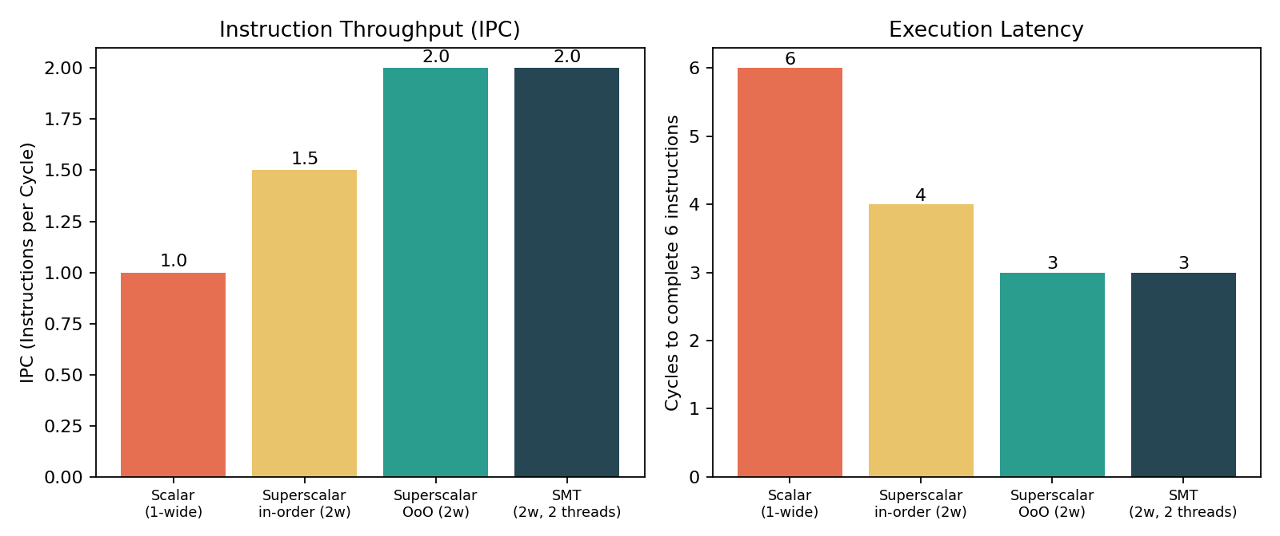
Fig 5.1 — IPC and cycle-count comparison across scalar, superscalar, OoO, and SMT configurations
5. Analysis of Results:
Configuration | Cycles (6 instr.) | IPC (Throughput)
Scalar (1-wide, in-order) | 6 | 1.00
Superscalar in-order (2-wide) | 4 | 1.50
Superscalar Out-of-Order (2-wide) | 3 | 2.00
SMT (2-wide, 2 threads) | 3 | 2.00 (combined)

- In-order superscalar already improves IPC to 1.50 by issuing 2 instructions/cycle, but I3's dependency on I1/I2 still forces a bubble in cycle 2/3.
- Out-of-order execution lets independent I4 and I6 fill that bubble, reaching the full 2.00 IPC — resource utilization of the 2-wide issue width becomes 100%.
- Speculative execution on branch I5 avoids stalling the pipeline for the branch outcome; at 88% predictor accuracy the average penalty is only 0.24 cycles/branch instead of a full 2-cycle flush every time.
- SMT reaches the same 2.00 combined IPC as OoO, but by a different mechanism — filling idle issue slots with an independent thread's instructions rather than reordering within one thread; this is why SMT helps most when a single thread has low ILP.
6. Conclusion:
Out-of-order superscalar execution and SMT both close the gap left by in-order issue and true dependencies, doubling instruction throughput (1.00 → 2.00 IPC) for this instruction mix, while speculative execution prevents branches from stalling the front-end — together these are the core techniques that let modern superscalar processors approach their theoretical issue-width throughput.

